

 **Loyola** institute of technology

and science

Department of INFORMATION TECHNOLOGY

Completed the project named as :

**MILITARY SOLDIER SAFETY**

Sumbitted by:

Team Members:

E.Sumithra(961222205053)

K.R.Sreenithi(961222205050)

S.Roja Poo(961222205044)

Abstract

Wearable technologies have the ability to change how we perceive, and make decisions about, our health and well-being. In the military, utilizing these emerging technologies in training or operations offers potential life-saving and performance enhancement benefits. Up until now, very limited physiological data collection has been performed due to the overall integration, form-factor, power limitations, and data feedback to the user from wearable monitoring devices. The explosion of the wearables sector in the commercial arena has pushed industry to solve a lot of these issues for the consumer market, allowing for new monitoring opportunities within the military as well. This manuscript discusses a couple of the use cases for wearable technologies within military environments, specifically heat stress injury prevention and performance monitoring during training. Additionally, some preliminary wearable device gold-standard testing is discussed.

1.INTRODUCTION

Currently, we have over 1700 sensors on high performance aircraft providing real-time feedback about hundreds of airframe parameters to monitor its performance and health status, yet only recently have we put the first sensor on the human who is piloting these multi-million dollar assets to monitor their performance and health status. This lack of physiological monitoring feedback holds true for every other Airmen, who perform their missions with the only health and wellness checks and Physical Fitness Testing (PFT), both occurring every 12 months, and is not linked in any way to the actual performance of their duties, training, or mission. The recent explosion of commercially available physiological monitoring technologies is therefore of significant interest to the military to help fill these human performance monitoring gaps. These technologies include wrist worn wearable devices such as various Fitbits, Garmins, Apple, and Sumsung devices, as well as strap-based devices such as certain Polar and Garmin products, alongside more research oriented devices such as Zephyr and Hidalgo Equivital.

2.RESULTS AND DISCUSSION

There are many physical demands placed on the warfighters of the DoD. Every Airman is required to maintain minimum physical fitness standard to remain in the Air Force. Every Airman can benefit from a higher level of health and wellness. Especially relevant to this idea of a smartphone based trainer and tracker is the news that the Air Force will be shutting down Health and Wellness Centers AF wide in the next year1. Military operators perform at an elite level, and can benefit from technologies that can allow them to perform at an even higher level from personalized training, tracking, and recovery. Physical training is an integral part of the warfighter’s daily performance, regardless of the mission space that they serve. Training effectively, getting the proper recovery and nutrition, and continuously being aware of your physical and cognitive workload can all lead to more productive and healthy lives; “What can be measured can be managed” (Drucker). By applying physiological monitoring technologies, being able to do all the things previously mentioned become possible. While there is an influx of commercial devices that address some of these issues, none of them are comprehensive in sensor metrics, and they have a very small amount of individualization, and are largely geared toward the average consumer and not the average military operator. With budget and manpower constraints on HP staff in the military, being able to train and track physical metrics remotely with a readily accessible software package becomes even more advantageous. Additionally, musculoskeletal injuries have a higher rate of occurrence with overtraining and inadequate recovery

2.1Use of Wearable Monitoring Technologies for Performance Monitoring

Recent advances in microelectronics, biotechnology, and nanotechnology have enabled new paradigms in wearable monitoring. Today we can monitor cardiac waveforms in a shirt or strap, G-forces using a simple accelerometer, and can analyze your stress from heart-rate-variability. Currently, there are two primary categories of commercially available physiological monitors; 1) consumer-grade highly wearable devices, but extremely low fidelity data and ruggedness (e.g. FitBit) and 2) research-grade higher fidelity data devices, but very complex with poor usability and wearability3. The DoD overall is taking multiple approaches to find wearables that fit military applications. First is to identify consumer-grade devices that have accuracy within acceptable limitations. At the Air Force Research Laboratory (AFRL), using both existing and novel technologies, we are working towards a fully integrated solution with streamlined and easy to understand data for a complete picture of health, wellness, stress, and advanced human performance for both civilian and military applications all over the world. These technologies can significantly enhance the safety of military operations, the effectiveness of disaster relief, and improve provision of health care in remote areas with limited infrastructure. More recently, specific focus has been on the physiological performance monitoring during selection and training for these programs, as well as the ability to monitor and maintain a high level of physiological readiness for current team members. The need comes from the lack of knowledge among these customers on the proper wearable device selection for physiological monitoring and the overwhelming amount of data that can be obtained from each device used.. Essentially this comes down to a sense-assess-augment loop, as shown below in Figure 1.

Figure 1.

Sense-Assess-Augment Loop Diagram.

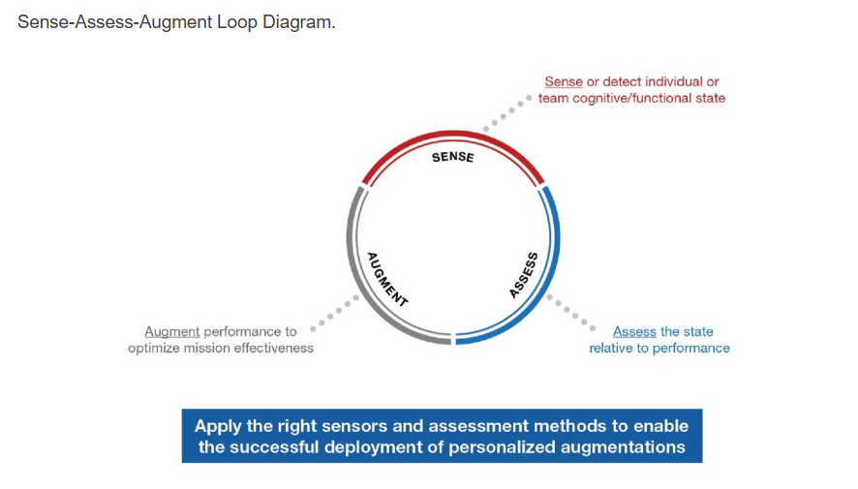

Selection of devices for the use case is usually a process of evaluating tradeoffs when attempting to use COTS devices. The usual parameters/features in question are measurement accuracy, wearability, ruggedness, general usability, battery life, ability to live stream physio data, and the ability to store/export data, and it’s usually a combination of multiple of these, not just one, that dictates the proper device. To help educate our military user groups, AFRL took the initiative to start performing testing, evaluation, and validation of wearable technologies that might be of interest. Figure 2 below shows the results of these early trials. In short, fifteen healthy young adults consented for participation in the heart rate and caloric expenditure trials of this study with average age 32.1±7, BMI 27.9±3.9 and percentage body fat 20.9±7.8 (mean ± SDFigure 2.

(Left) Comparison of mean of difference between Polar and various evaluated devices for heart rate during resistance training, running, cycling, and rowing. (Right) Percentage number of outliers for different beat intervals during resistance training trials.

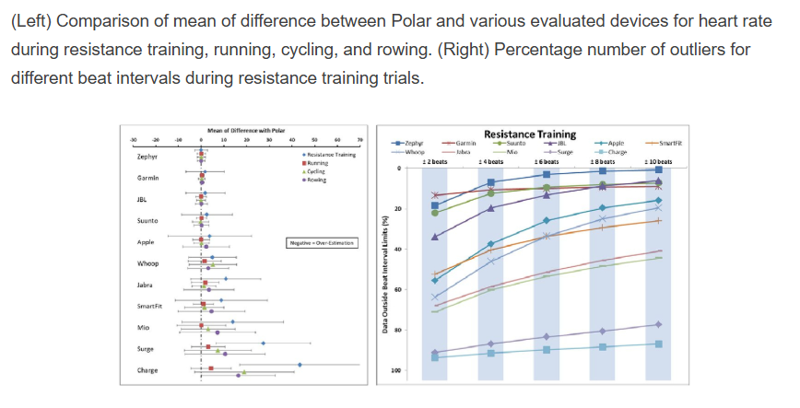

Comparison of group averages were tabulated for heart rate against the Polar device. It should be noted that a mere comparison of group means does not reflect the reliability of a device and that the difference of values between each wearable device and its reference device gives a more realistic comparison. This data can be seen for heart rate Figure 1 (left). Additionally, if a device has fixed bias, the values of the wearable devices can be adjusted to match the reference system; however, limits of agreement should be used to determine if the devices can be used interchangeably.

During resistance training trials, all of the devices displayed a significant fixed bias and a significant proportional bias for heart rate data. However, the limits of agreement of the heart rate data were minimal for Zephyr. During running trials, 6 of the 7 devices displayed a significant fixed bias, and 6 of 7 devices displayed a significant proportional bias for heart rate. Mio did not show a significant fixed bias, and SmartFit did not show a significant proportional bias during the running trials. The limits of agreement for this trial were minimal for Garmin. During cycling trials, all 7 devices displayed a significant fixed bias for heart rate, however only Zephyr, Mio, Garmin, and Suunto showed a significant proportional bias for heart rate. The limits of agreement for cycling were minimal for Garmin for heart rate. Finally, for heart rate data during rowing trails, significant proportional bias was present in all of the devices, while significant fixed bias was displayed in 6 of 7 devices. Zephyr was the only device that did not display a significant fixed bias for heart rate during rowing trials.

There are multiple things this data demonstrates, with the most important being that chest strap devices are less affected by the type of activity than wrist worn or even in-ear devices. Chest strap devices in the upper torso appear to stay in position better throughout a wide variety of movements. Another observation is that choice of device should be dictated first by primary type of activity being monitored, then by user comfort/compliance, and finally be acceptable device accuracy. For example, if the activity is primarily running, a wrist worn device may be acceptable as the accuracy is still within a reasonable limit, and user comfort/compliance will be higher than with a chest worn device. However, if the activity requires strenuous activity with an increased amount of variety of movements, such as in the resistance training example above, a chest strap device is the only adequate option as the wrist worn devices are still only within +/- 6 bpm for 70% of the data (best case scenario, as seen with the Apple iWatch. Interestingly, some devices had large amounts of missing data (60-80%), which it was concluded that it was due to adaptive data sampling rates in the device to either conserve battery or memory.

Once devices are chosen, collection of performance data over time, in conjunction with quantitative performance metrics, is needed to start to combine various data streams and develop predictive performance models. In athletics, the quantitative performance data can come from game stats and sport positional metrics (i.e. 40-yd dash times). For the military, this is much more difficult to define and is an on-going problem attempting to be solved as different units have different roles and thus different performance targets or standards. As discussed previously, the objective with aggregating the performance data will be to develop predictive algorithms for personalized training and tracking to maximize the operational readiness and effectiveness of any operator and provide real-time feedback to training cadre or command staff. A conceptual view of this interface can be seen below in Figure 3.

Figure 3.

Conceptual interface for data aggregation and feedback system.

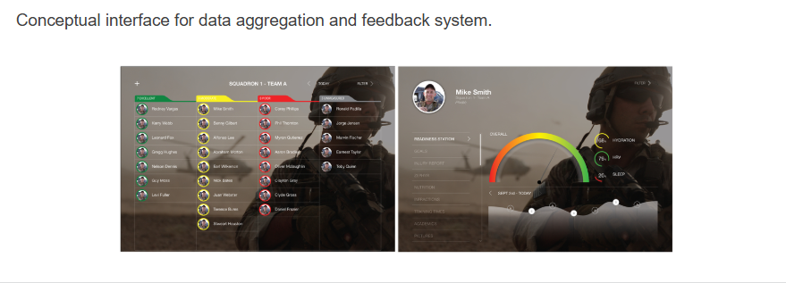

2.2Use of Wearable Technologies for Health and Safety Monitoring

Statistics show that in a 3-year period, as much as 600 medical events occurred during the training pipeline10. Over a 14 year period (1977-2001), 126 non-traumatic sudden deaths occurred during U.S. basic military training11. Specifically, heat stroke is responsible for 2.5% of deaths in each branch of service including the Army, Navy, Marine Corps, and Air Force11. Wearable devices that provide real-time physiological changes due to exertion may aid in early identification of potential for heat stress illness/injury, which can prevent or mitigate a more serious event.

The U.S. Army Research Institute of Environmental Medicine (USARIEM) developed the Estimated Core Temperature, or ECTemp, algorithm which provides accurate estimates of core temperature simply by recording heart rate, allowing mission leaders to detect if a soldier is at risk of heat stress illness. The ECTemp algorithm uses minute-to-minute measures of heat rate to accurately estimate core body temperature. The algorithm was licensed to Zephyr Technology a few years ago to use as one of the features of its Bioharness, which would monitor team member health statuses to prevent and mitigate injury.

Figure 4.

Zephyr BioHarness and System Functionality

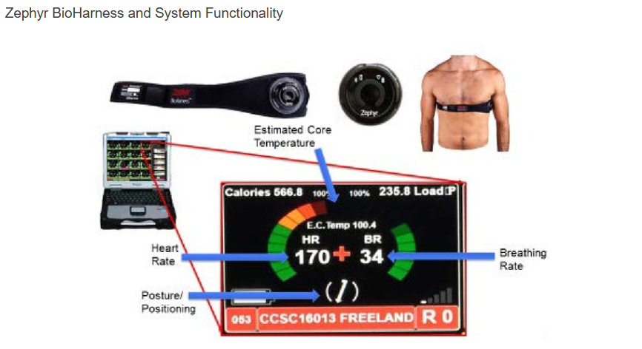

Real-time physiological monitoring has the potential to reduce the number of heat stress events by alerting members of the cadre when trainee vital signs are out of range for an extended period of time. In addition, instances may occur where several trainees are experiencing high “estimated core temperatures” or heat rate levels that exceed 80% of one’s maximum heart rate. Exercises that increase the likelihood of a heat stress event can be mitigated by embedding cooling techniques into the task (i.e., moving the event into an aquatic environment, adding cooling gear, increasing the number of breaks between bouts of exercise). The example below (Figure 5) led to a specific request for vital signs to be continuously monitored during high stress events. Heart rate data was collected during a military training course during a ruck march on extended training day (ETD). The red line represents this trainee’s heart rate during the task (~3:00-4:12AM). At some point during this ruck march, this trainee’s “beats per minute” rose above 80% of his maximum heart rate (blue line) and for longer than 20 minutes. Also shown on the bottom right is a comparison of the heart rate trends between another trainee in the course and this particular trainee. Following this extended increase, the trainee fell to the ground and was treated by the medical staff on site. It was determined that the trainee should not complete the event, thus, he was unable to continue the training course. This event motivated the Course Chief as well as the research team to establish performance and safety monitoring as a standard during such high stress events.

Figure 5.

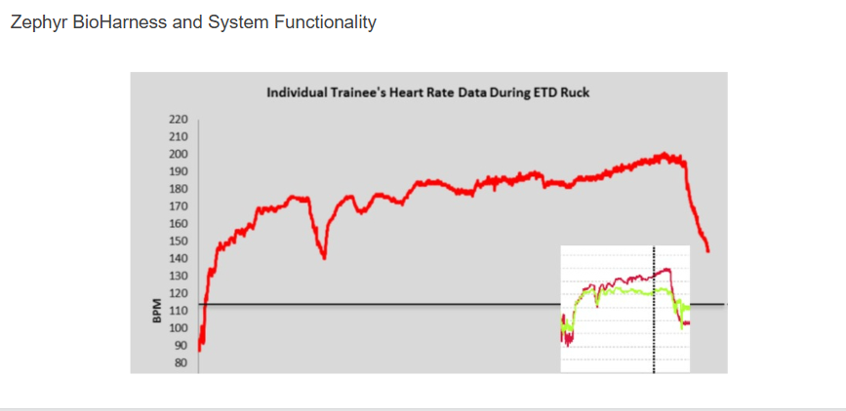

Zephyr BioHarness and System Functionality

Over a one year time span, greater than 1,942 potential heat stress events were monitored during high stress events. During these events, 5 situations led to a near loss of conscious, thus was recorded as a missed event. However, high ECTs and/or irregular heart rate patterns were not signaled in these situations. Rather, exhaustion better exemplifies these specific cases. There was a total of 90 events that were mitigated and ranged from zero interference with training to the identification of vitals that needed checked and ended with the trainee unable to complete the task (there is no indication of return vs. no return to the course). Of these events, 77.89% led to the trainee either staying in training or returning back to training once a mitigation was in place such as hydration or movement into a cooler environment. This 77.89% was estimated to save the Air Force ~$1M in possible washback trainee costs. Moreover, 16.84% of events led to further assessment during training and a medical decision to send the trainee to medical for further evaluation. Though we were unable to track if each of these events led to a return to training or a washback into a later course, the medical evaluation may have alleviated a more serious health issue that may have otherwise been unidentified.

Coding :

import random

import time

# Simulated sensor data generator

def get_soldier_data():

data = {

"heart_rate": random.randint(40, 130), # bpm

"body_temp": round(random.uniform(35.0, 40.0), 1), # °C

"location": (random.uniform(20.0, 21.0), random.uniform(78.0, 79.0)), # Lat, Long

"movement": random.choice(["Moving", "Stationary", "Fallen"])

}

return data

# Check for safety violations

def analyze_data(data):

alerts = []

if data['heart_rate'] < 50 or data['heart_rate'] > 120:

alerts.append(f"⚠️ Abnormal heart rate: {data['heart_rate']} bpm")

if data['body_temp'] < 36.1 or data['body_temp'] > 38.0:

alerts.append(f"⚠️ Abnormal body temperature: {data['body_temp']} °C")

if data['movement'] == "Fallen":

alerts.append(f"⚠️ Soldier might be injured (Status: {data['movement']})")

return alerts

# Main loop

for i in range(5): # Simulate 5 data readings

print(f"\n--- Reading {i+1} ---")

soldier_data = get_soldier_data()

for key, val in soldier_data.items():

print(f"{key.capitalize()}: {val}")

alerts = analyze_data(soldier_data)

if alerts:

print("\n‼️ ALERTS:")

for alert in alerts:

print(alert)

else:

print("✅ Soldier status normal.")

time.sleep(1)

🖥️ Output:

yaml

Copy

Edit

--- Reading 1 ---

Heart_rate: 88

Body_temp: 36.5

Location: (20.5623, 78.9234)

Movement: Moving

✅ Soldier status normal.

--- Reading 2 ---

Heart_rate: 130

Body_temp: 39.1

Location: (20.6892, 78.1023)

Movement: Fallen

‼️ ALERTS:

⚠️ Abnormal heart rate: 130 bpm

⚠️ Abnormal body temperature: 39.1 °C

⚠️ Soldier might be injured (Status: Fallen)

3.CONCLUSIONS

The technologies discussed in this manuscript have the potential to alter the way physical training, recovery, and readiness are managed. This could potentially lead to musculoskeletal injury reduction, decreased physical training costs, improved retention by improving PFT scoring. While all of these concepts have benefits beyond the military, the specific beneficiary in the military of this efforts are the operators themselves. The technologies will be custom designed for their mission space for the purpose of improved physical and cognitive performance, improved situational awareness of team readiness, potential to reduce injuries through real-world recovery predictions, and amongst numerous other benefits. Future technical challenges that are faced with wearable devices are: high wearability, high durability/ruggedness, extended battery life, and secure data communication/transfer methods. Specific data analytics/algorithm challenges are: large data sets, varying time scales of physiological data, model development with limited replicates (individuals), and relating the physiological data to real-world performance. Additionally, in the future, incorporation of real-time biomarker detection platforms will further enhance the predictive power of these algorithms. These devices will need to be low-cost, expendable or reusable, highly selective to the analyte, have high sensitivity/accuracy, and be minimally invasive to the user.